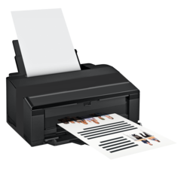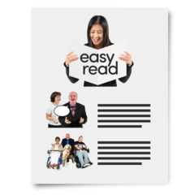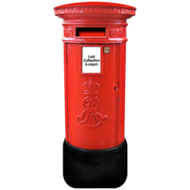 | Hi friends of Get on Board  Please print this newsletter to share with lots of people.  If you would like us to send you a printed newsletter in the post please let us know.
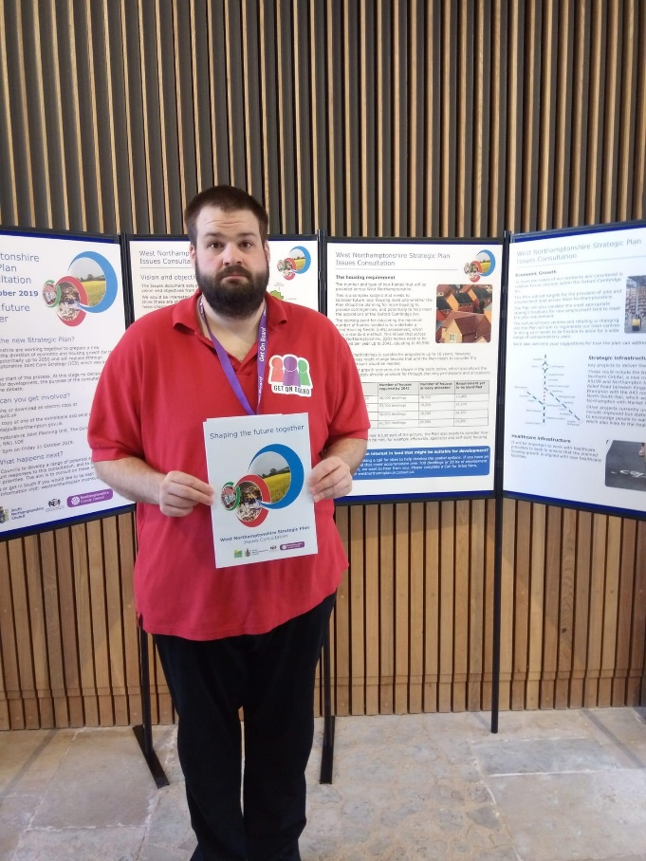  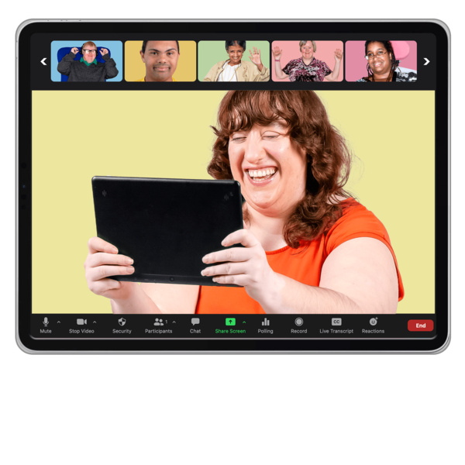  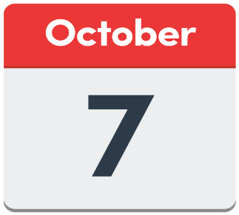 | GOB news  Mike attended West Northamptonshire’s Strategic Plan on November 11th 2021. Mike has signed up for more information, so he can monitor what facilities are being planned for people with disabilities.  Mike is also keeping an eye on what a group named Snap are doing in Milton Keynes to see if we can replicate what they do in Northamptonshire, especially the “Snappy Hour” radio show they have on a Sunday Morning from 12 noon till 1pm. Tune in on FM105.5 to find out more.  Angela has taken part in a Zoom meeting with NGH. She’s been keeping up to date on what improvements they are making for people with disabilities. They have produced a pregnancy guide in Easy Read. NGH are working closely with KGH to produce a joint hospital passport.  Conference  The conference has now been changed to the 7th October 2022,so watch this space for more information.
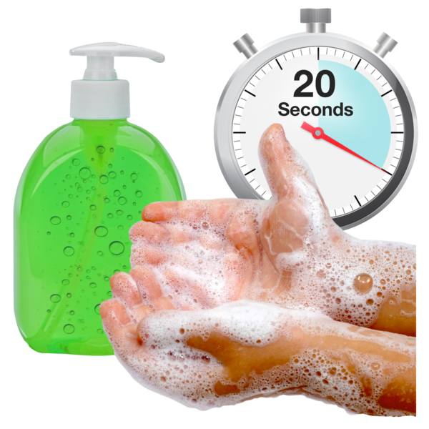 | Covid news/updates  Although Covid19 restrictions are being relaxed it is still very important that you continue to be safe and follow current guide lines.
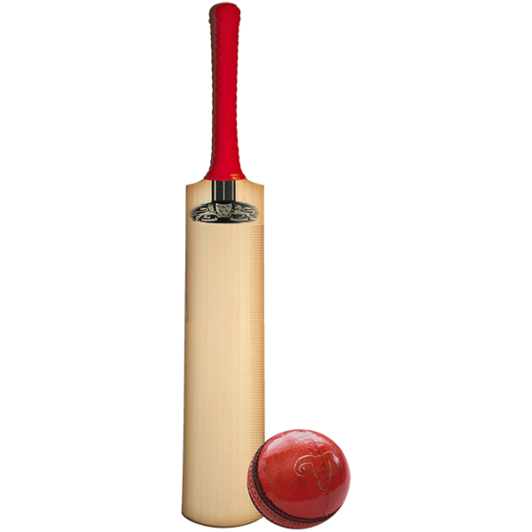  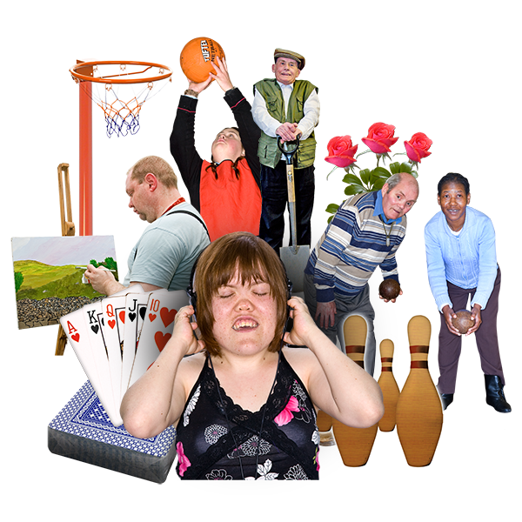 | Sport  Northants County Cricket Club are looking to get more disabled people to play cricket and are looking at opening Hubs across the county.  Age UK have set up Bowls sessions at Kettering/Desborough Indoor Bowls club. This is running on Fridays 11:45 am till 2pm for people with disabilities.
If you have any ideas of things you would like Get On Board and the Champions to do you can let us know by
Email – Info@getonboarduk.com
Call - Carol 07793 407848
Dawn 07825 301850

